Project Design Phase-II
Technology Stack (Architecture & Stack)
Date | 28 September 2026
Team ID | SWTID-2026-5228
Project Name | Import Data using Transform Maps (Spreadsheet)
Maximum Marks | 4 Marks
Technical Architecture:
The Deliverable shall include the architectural diagram as below and the information as per the table1 & table 2
Example: Importing customer data from Excel into ServiceNow using Import Sets and Transform Maps
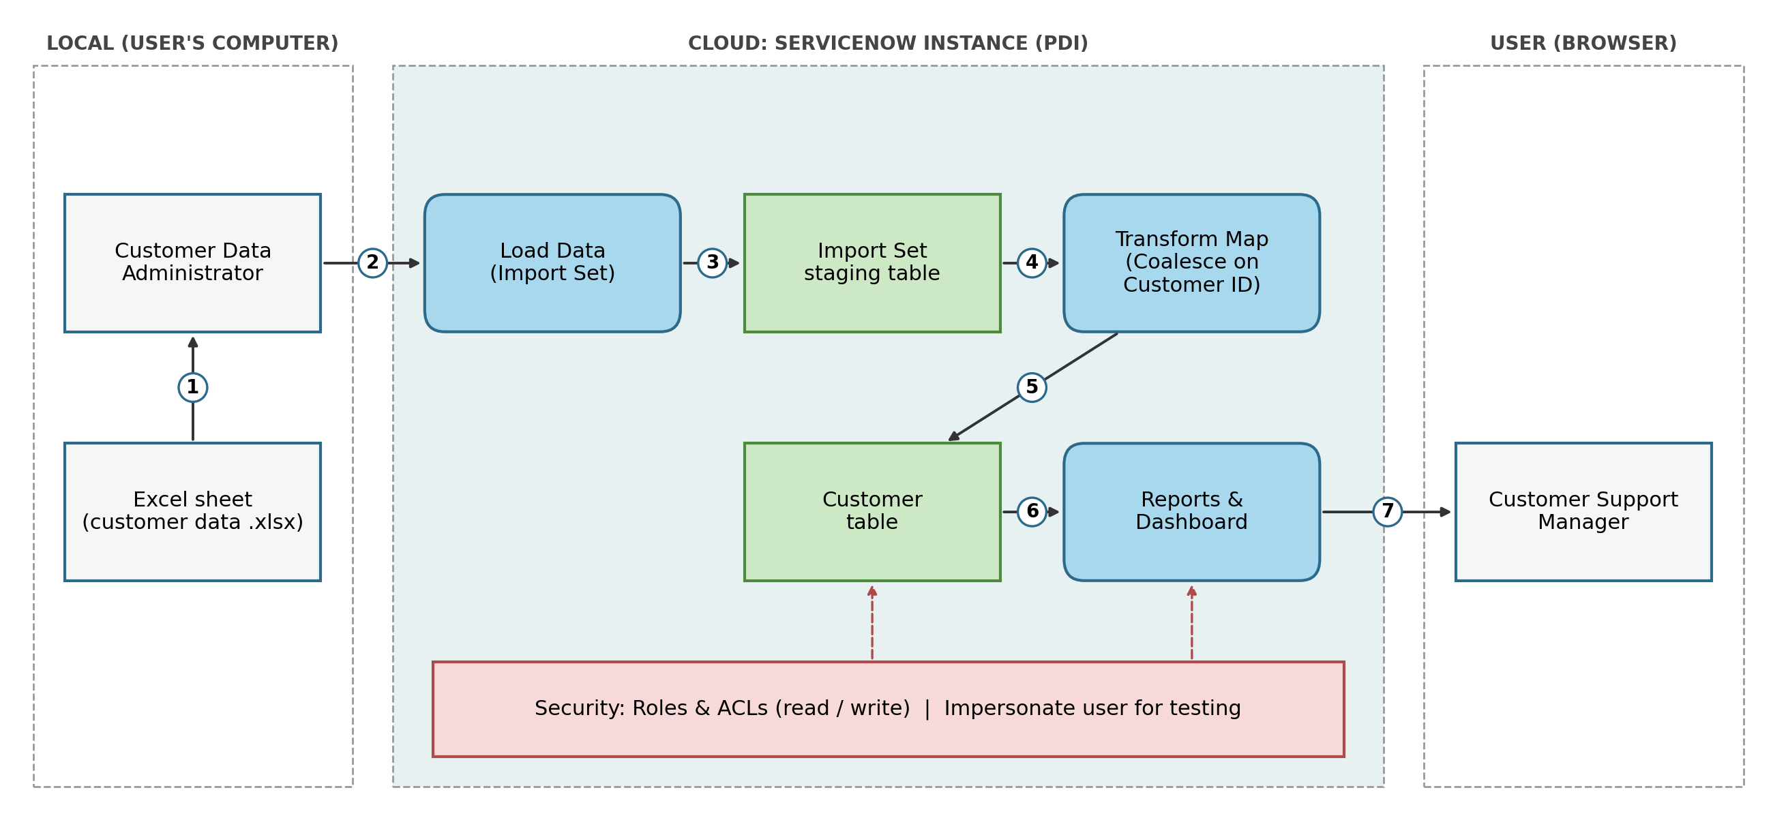
Flow: 1 Excel sheet given to the administrator, 2 file uploaded with Load Data, 3 rows saved in the staging table, 4 Transform Map runs with Coalesce, 5 records stored in the customer table, 6 reports and dashboard built, 7 support manager views them. Roles and ACLs protect the customer table and reports.
Table-1 : Components & Technologies:
S.No | Component | Description | Technology
1. | User Interface | How the administrator and support manager interact with the application (Load Data page, list and form views, reports and dashboard) | ServiceNow web UI in a browser
2. | Application Logic-1 | Loads the Excel file into the Import Set (staging) table | ServiceNow Import Sets (System Import Sets > Load Data)
3. | Application Logic-2 | Maps source fields to target fields and updates existing customers using Coalesce on Customer ID | ServiceNow Transform Maps, Auto Map Matching Fields, Mapping Assist
4. | Application Logic-3 | Builds the pie chart by account type, the bar chart by city and the dashboard | ServiceNow Reports and Dashboards
5. | Database | Custom customer table with its fields, and the Import Set staging table | ServiceNow tables (Customer table, Import Set table)
6. | Cloud Database | Database service on the cloud that stores the imported customer data | ServiceNow cloud instance database (Personal Developer Instance)
7. | File Storage | Source customer data file (.xlsx) prepared and uploaded from the local computer | Microsoft Excel / Google Sheets, local file system
8. | External API-1 | No external API is used; data is loaded by manual file upload | Not applicable
9. | External API-2 | Not used in this project | Not applicable
10. | Machine Learning Model | Not used in this project | Not applicable
11. | Infrastructure (Server / Cloud) | Application deployment on cloud | ServiceNow Personal Developer Instance (cloud)  Local Server Configuration: Not required, accessed through a browser  Cloud Server Configuration: ServiceNow-hosted instance
Table-2: Application Characteristics:
S.No | Characteristics | Description | Technology
1. | Open-Source Frameworks | No open-source framework is used; the solution is built with the built-in ServiceNow platform features | ServiceNow platform tools (Import Sets, Transform Maps, Reports)
2. | Security Implementations | A custom role and ACLs give read and write access to the customer table only to authorised users, and access is tested by impersonating users | ServiceNow Roles, ACLs, Elevate Role (security_admin), Impersonate User
3. | Scalable Architecture | The same Transform Map is reused for new spreadsheets, more fields can be added to the table, and imports can later be scheduled | ServiceNow Import Sets, Transform Maps, Scheduled Imports
4. | Availability | The application runs on the ServiceNow cloud instance and is available whenever the instance is running | ServiceNow cloud instance (PDI)
5. | Performance | Rows are loaded in bulk into a staging table, the transform runs within seconds, and the Transform History shows the inserted, updated and ignored counts | Import Set staging table, Coalesce field, Transform History
References:
https://c4model.com/
https://developer.ibm.com/patterns/online-order-processing-system-during-pandemic/
https://www.ibm.com/cloud/architecture
https://aws.amazon.com/architecture
https://medium.com/the-internal-startup/how-to-draw-useful-technical-architecture-diagrams-2d20c9fda90d

